Contents

MY REFERENCE LINKS 3

SCENARIO 1: CHICKEN KITCHEN EXPANSION 5

SCENARIO 2: WHERE SHOULD THE PAYDAY LENDING BRANCH GO? 7

SCENARIO 3: SCOUTING FOR A SPORTS STADIUM 9

WEEK 1 ASSIGNMENT: EXECUTIVE SUMMARY 11

WEEKS 2 AND 3 ASSIGNMENT: TECHNICAL REPORT 13

TECHNICAL CUTTING EDGE APPROACH TO VISUALIZATION AND COMPARISON 15

MY GENERAL APPROACH AND COMPARISON CONCEPTS 16

My Main References (quoting from) 16

Elements 17

HOCKEY 18

OVERALL PERTINENT INFORMATION 20

LEXINGTON, KY 21

FAYETTE COUNTY, KY 22

COMPARISONS 27

COMPARISON - SPORTS REPRESENTATION 27

COMPARISON - AIRPORTS 28

* *Austin TX should have a NHL expansion hockey team ! Called Austin Armadillos* 
  + This would be the second team in Texas, and CA has 3 NHL teams
  + TX has a population of XYZ people, it is the x largest state by population
  + People spend money on sports
  + Dallas stars are in fact a big hit !
* California
  + 4 NBA teams: Golden State Warriors Los Angeles Clippers Los Angeles Lakers Sacramento Kings
* NFL:
  + **Houston** and Dallas NFL teams
* NBA:
  + 3 NBA teams: Dallas Mavericks, **Houston** Rockets, San Antonio Spurs
* NHL: Dallas Stars
* Austin
  + has no major league sports teams (no NFL, no NBA, no NHL)

# MY REFERENCE LINKS

* Templates:
  + <https://drive.google.com/drive/u/4/folders/1c4o7eR1BkJlgnk3YV8wY_1B2K3QggjWR>
  + <https://docs.google.com/presentation/d/1_yr-4axvWcPjeAjyhfQh6BnDFcX7YKJFH3ukyPrzaoc/edit#slide=id.g74174a686c_0_44>
  + <https://docs.google.com/document/d/1ClSFKse8b8SarDr_bBm2dMu0venu6TNa7dkhqHVNyFs/edit>
  + <https://drive.google.com/drive/u/4/shared-with-me>
  + <https://drive.google.com/drive/u/4/folders/1c4o7eR1BkJlgnk3YV8wY_1B2K3QggjWR>
* <https://censusreporter.org/>
* <https://ebookcentral-proquest-com.proxy.lib.umich.edu/lib/umichigan/reader.action?docID=4187267&ppg=18>
* <https://ebookcentral-proquest-com.proxy.lib.umich.edu/lib/umichigan/detail.action?docID=4187267>
* <https://ebookcentral-proquest-com.proxy.lib.umich.edu/lib/umichigan/reader.action?docID=4187267&ppg=18>
* Main Library: <https://guides.lib.umich.edu/mads>
* <https://state.1keydata.com/nfl-teams-by-state.php>
* List of states by population:
  + <https://en.wikipedia.org/wiki/List_of_states_and_territories_of_the_United_States_by_population>
* Main:
  + <https://censusreporter.org/>
* Examples of Executive Summaries:
  + <https://drive.google.com/drive/u/4/folders/1J4isTezbs1Yplzbn-pqxvUZqR7U8ejT8>
* Racine City WebLink
  + <https://www.cityofracine.org/Home/>
* The Actual Assignment:
  + <https://docs.google.com/document/d/1645nNBesR7ZV63Cv6JiF4vEAjtMP0hOsL24jfwwMBok/edit>

**Audience for Your Deliverables**

Your audience is the company CEO and their executive team. They are intelligent and lead a functional workplace. You don’t have to worry about backstabbers or manipulators; good ideas, supported with evidence and good explanations, tend to be adopted. That being said, they are very busy and have limited time for you to present your arguments. They believe in the power of data to point the way toward future company growth, and the Board of Directors insists on data-driven decisionmaking. However, while the CEO is not averse to data (they hired you, after all!), they do not have a background in data science or highly-technical analysis. Therefore, you will need to use language, design strategies, and tools that are easily understood outside the sphere of data scientists. (Pro tip: while the leadership team are novices with data science, they are sticklers for data labels. ) They will push for you to do due diligence, consulting consumer and demographic data from a variety of sources.

**Sources**

We’ve gotten you started with recommended sources, and they should form the core of your supporting evidence. However, you are welcome to go above those resources, such as those organized [on this list](https://guides.lib.umich.edu/mads) by UMSI’s librarian Shevon Desai. You can reach out to her ([shevonad@umich.edu](mailto:shevonad@umich.edu)) for additional research support.

# 

# 

# 

# 

# 

# 

# 

# 

# 

# 

# 

# 

# 

# SCENARIO 1: CHICKEN KITCHEN EXPANSION

We’ll use this example in course lecture, having selected Frederick County, Maryland, and Kendall County, Texas, as our counties to compare. The franchise department of Chicken Kitchen is asking for your help in identifying a new location for them to expand into based on applications from two counties. Chicken Kitchen considers itself “premium fast casual with great service.” It appeals to consumers willing to pay a dollar or two more than budget fast food prices for food with “clean” ingredients (e.g., no preservatives), friendly service, and delicious taste. Successful locations tend to be in communities that are more conservative, higher income, younger, and in areas that are more recently built up. Chicken Kitchen locations near other upscale fast food restaurants like Chipotle, CoreLife, and Qdoba are more profitable than those near McDonald’s or Taco Bell.

Chicken Kitchen does well in locations that are more newly developed, with highway proximity, household income above the national median, car culture (as opposed to reliance on public transportation), there is room for continued population growth and development, where there is a dining-out culture, and where culture skews more conservative.

**Your task**

Chicken Kitchen is determining how to expand its store geographies. They have provided you with two counties to research. Over the course of this term, you will determine which county is more advantageous and identify action steps the organization should take within the preferred county. You should include, in your report, why the other county is rejected.

Don’t feel like you need to keep researching until you find one county that is the clear “winner” and another the clear “loser.” As you will see in the course lectures, there is no single “right” answer: one county might be best for immediate expansion, and another might be better if the company chose to wait a few years until anticipated population growth and civic infrastructure strengthens. The goal of the assignments in this course is to effectively communicate your decision in a way that it can be interpreted effectively by the executive team, not to make a slam-dunk case.

You will use government and proprietary consumer data to get to know the people and dynamics within the county. Do the county demographics make sense for Chicken Kitchen’s desired market? And while there may be one good location for a Chicken Kitchen in the county you choose, the ideal county should have the option for at least a second location. Remember: Chicken Kitchen’s logo is PINK.

**Counties to Study**

Please choose one county from each column for your work. Do not replicate the class sample by choosing Kendall County and Frederick County.

|  |  |
| --- | --- |
| MICHIGAN COUNTIES  Grand Traverse County, MI  Kalamazoo County, MI  Oakland County, MI  Macomb County, MI  Marquette County, MI  Alpena County, MI  Livingston County, MI  Genesee County, MI  Mecosta County, MI  Isabella County, MI  Lapeer County, MI  Saint Clair County, MI | OTHER COUNTIES  Lucas County, OH  Albemarle County, VA  Sacramento County, CA  Racine County, WI  Woodbury County, IA  Shelby County, TN  Bay County, FL  Ellis County, KS  Lubbock County, TX  Stearns County, MN  Orange County, NC  Bergen County, NJ |

**Getting Started with Research**

Consult, at a minimum, these data sources. You may wish to screenshot, download, or otherwise keep a folder of your research throughout the course, as you may refer back to it as the assignments progress.

1. To quickly orient yourself to the two counties access the latest American Community Survey data (ACS, from U.S. Census), and current estimates on per capita income, median household income, education levels (that may be a proxy for income stability), and employment figures, do a search at [CensusReporter.org](https://censusreporter.org). Keep an eye out for the cross that indicates that, due to smaller sample size or other factors, margin of error may be >10%.
2. To see past, current estimated, and five-year predictive data about your zip code, access the database [Demographics Now](https://search.lib.umich.edu/databases/record/30002?query=%22demographics%20now%22&utm_source=MLibrary) (requires U-M authentication). In the top-right corner, type in and choose your county. Then click the “Demographics” tab and choose “Summary” from the left pulldown menu. From the right pulldown menu, look at each of these reports:
   1. Basic Demographic Summary Chart
   2. Complete Demographic Summary Report
3. To get a sense of consumer spending for your county, use [DemographicsNow](https://search.lib.umich.edu/databases/record/30002?query=%22demographics%20now%22&utm_source=MLibrary). After logging in and typing in your county:
   1. Select the Demographics tab from the top, then Summary and at least these three reports that use *indices*:
      1. Consumer Expenditure Restaurant Detail Summary
      2. Consumer Expenditures Food, Beverage, Grocery Detail Summary
      3. Simmons Lifestyle Demographic Statements Survey
   2. To view persona data in narrative form, select Demographics > Summary> Mosaic Population Summary Index Report. Click on each population to view persona details. Pay particular attention to pages 1 and 4, the narrative descriptions. Page 2 is useful if you want to get a sense of statistics for this type of consumer at the national level (so it’s not indicative of your zip code, necessarily), and Page 3 gives some explanations.
4. You will also want to investigate county-level data that may be available to you in [FRED](https://fred.stlouisfed.org/). Try typing in your county name and state abbreviation to explore what kinds of relevant data are available for your county.
5. Check your instincts -- and think about your recommended action steps -- by using tools like Yelp, Google Maps, or others to get a sense of the competition in this area.

# SCENARIO 2: WHERE SHOULD THE PAYDAY LENDING BRANCH GO?

The CEO of the Lighthouse Payday Lending Company has asked you to run data for two counties to determine which county has the demographics most suited to expansion. Lighthouse provides short-term loans to bridge between pay periods -- but it has revolutionized the industry and won over critics by charging fair market rate for those loans (instead of the high-interest rates that have pervaded the industry).. Consider the type of consumer most likely to need payday lending services: those with low and/or fluctuating income, minimal wealth, and less overall stability. Successful Lighthouse locations are more likely to be found in lower-income communities, those with income instability, and those with a large number of low-wage workers. Your client also wants to invest in a location where the population is stable or growing and where there is the potential to add a second location in the county you chose.

**Your task**

Choose one county from each column to research. Over the course of this term, you will determine which county is more advantageous and identify action steps the organization should take within the preferred county. You should include, in your report, why the other county is rejected.

Don’t feel like you need to keep researching until you find one county that is the clear “winner” and another the clear “loser.” As you will see in the course lectures, there is no single “right” answer: one county might be best for short-term profit, and another might be a long game choice. The goal of the assignments in this course is to effectively communicate your decision in a way that it can be interpreted effectively by the executive team, not to make a slam-dunk case.

The goal of the assignments in this course is to effectively communicate your decision in a way that it can be interpreted effectively by the executive team. You will use government and proprietary consumer data to get to know the people and dynamics within the county. Do the county demographics make sense for Lighthouse? And while there may be one good location for one location in the county you choose, the ideal county should have the option for at least a second location. Be sure to check Yelp to make sure there won’t be too much competition in your location of choice. Lucky for you, LIghthouse is redoing its brand standards, so design choices are up to you.

**Counties**

Choose one county from each column.

|  |  |
| --- | --- |
| MICHIGAN COUNTIES  Genesee County, MI  Berrien County, MI  Oakland County, MI  Roscommon County, MI  Menominee County, MI  Presque Isle County, MI  Hillsdale County, MI  Alger County, MI  Cass County, MI  Eaton County, MI  Benzie County, MI | OTHER COUNTIES  St. Joseph County, IN  Monroe County, AL  Cass County, ND  Bennington County, VT  Yuma County, AZ  Allegheny County, MD  East Baton Rouge Parish, LA  Ashtabula County, OH  Oneida County, NY  Morris County, NJ  Hamilton County, TN |

**Getting Started with Research**

Consult, at a minimum, these data sources. Consult, at a minimum, these data sources. You may wish to screenshot, download, or otherwise keep a folder of your research, as you may refer back to it as the assignments progress.

1. To quickly orient yourself to the two counties, access the latest American Community Survey data (ACS, from U.S. Census), and current estimates on per capita income, median household income, education levels (that may be a proxy for income stability), home ownership, and employment figures. Start with [CensusReporter.org](https://censusreporter.org). Keep an eye out for the cross that indicates that, due to smaller sample size or other factors, margin of error may be >10%.
2. At [FRED](https://fred.stlouisfed.org), search for “subprime credit” and the name of your county to view Equifax’s Subprime Credit data over time. Look into SNAP benefits for your counties as well. What other data does FRED have that might help illuminate your scenario?
3. To study demographics over time, as well as consumer personas for the county, access the database [Demographics Now](https://search.lib.umich.edu/databases/record/30002?query=%22demographics%20now%22&utm_source=MLibrary) (requires U-M authentication). In the top-right corner, type in and choose your county. Then click the “Demographics” tab and choose “Summary” from the left pulldown menu. From the right pulldown menu, look at each of these reports:
   1. Basic Demographic Summary Chart
   2. Complete Demographic Summary Report
   3. Mosaic Population Summary Index Report: Click on each group’s name to view persona details. Pay particular attention to pages 1 and 4, the narrative descriptions. Page 2 is useful if you want to get a sense of statistics for this type of consumer at the national level (so it’s not indicative of your zip code, necessarily), and Page 3 gives some explanations.
4. Check your instincts by using tools like Yelp, Google Maps, or others to get a sense of the competition in payday lending or in other businesses that cater to lower-income residents.

# SCENARIO 3: SCOUTING FOR A SPORTS STADIUM

The [Federal Hockey League](https://www.federalhockey.com) is looking to expand its [Western Division](https://www.federalhockey.com/stats#/182/teams?division_id=7955). They have narrowed down their potential locations to two cities.

There are so many minor league hockey teams that it is getting more and more difficult to find a market in which to expand.

Successful locations tend to be in thriving, smaller cities not already served by National Hockey League (NHL), large university teams or major-league sports teams.

They need to be located in communities that are predicted to be stable or growing -- in both income and population -- in the coming years.

There should already be some local dining options and a sense that consumers in this area spend money on eating out, which provides significant additional revenue beyond ticket sales.

You should also search online to make sure that you are aware of existing sports teams in the two communities -- you will want to find a city in which there is a balance of sports fans but not excessive competition.

**Your task**

Choose one city from each column below. Over the course of this term, you will determine which location is more advantageous and identify action steps the organization should take next. You should include, in your report, why the other city is rejected.

Don’t worry about identifying a clear “winner” or “loser.” As you will see in the course lectures, there is no single “right” answer: one city might be best for immediate expansion given its current population and amenities, for example, but another might be better given future projections. The goal of the assignments in this course is not to pick the “right” answer but to effectively communicate your decision in a way that it can be interpreted effectively by the executive team. You will use government and proprietary consumer data to get to know the people and dynamics within the county. Tools like Yelp and Google maps will help you, too. Do the city’s consumer habits and demographics make sense for FHL’s goals? As you work through your deliverables, be sure to browse the websites of other hockey teams to get a sense of the design styles, colors, and fonts that epitomize this sport.

**Cities to Choose From**

Choose one from each column.

|  |  |
| --- | --- |
| MICHIGAN CITIES  Alpena, MI  Cadillac, MI  St. Joseph, MI  Michigan city of your choice | OTHER CITIES  Racine, WI  Hays, KS  Lexington, KY  Other city of your choice |

<https://www.wwnytv.com/2020/04/04/saturday-sports-watertown-wolves-new-majority-shareholder-is-bringing-new-ideas-table/?fbclid=IwAR187wb47n4_bv6Y4N9Sxs9relftDDa09hgi313dXKat7aFQpcmSXSAiWdw>

**Getting Started with Research**

Consult, at a minimum, these data sources. You may wish to screenshot, download, or otherwise keep a folder of your research throughout the course, as you may refer back to it as the assignments progress.

1. To quickly orient yourself to the two cities, access the latest American Community Survey data (ACS, from U.S. Census), and current estimates on per capita income, median household income, education levels (that may be a proxy for income stability), and employment figures, do a search at [CensusReporter.org](https://censusreporter.org). Keep an eye out for the cross that indicates that, due to smaller sample size or other factors, margin of error may be >10%.
2. To look at demographics over time, as well as consumer personas for the county, access the database [Demographics Now](https://search.lib.umich.edu/databases/record/30002?query=%22demographics%20now%22&utm_source=MLibrary) (requires U-M authentication). In the top-right corner, type in and choose your municipality. Then click the “Demographics” tab and choose “Summary” from the left pulldown menu. From the right pulldown menu, look at each of these reports:
   1. Basic Demographic Summary Chart
   2. Complete Demographic Summary Report
   3. Mosaic Population Summary Index Report (click on each population to view personas)
   4. Simmons Entertainment, Leisure, Dining Summary
   5. Consumer Expenditure Food, Beverage, Grocery Detail Summary
3. Because FRED only has county-level data, it is unlikely to be helpful for this scenario.
4. Check your instincts by using tools like Yelp, Google Maps, or others to get a sense of the competition in this area. Be careful: There are a surprisingly high number of minor league hockey teams in America!

## 

# 

# 

# WEEK 1 ASSIGNMENT: EXECUTIVE SUMMARY

After watching the first week’s lecture, choose two geographies from your chosen scenario. Research each area, consulting at least the resources listed. Then determine which location you will recommend. Then, using the [templates provided](https://drive.google.com/drive/folders/1c4o7eR1BkJlgnk3YV8wY_1B2K3QggjWR) (see document in the folder for how to make a copy of templates), or a design of your own choice, create a one-page executive summary using the slidedoc format described in lecture.

You will submit your Executive Summary as a .PDF file to ensure that your design elements will appear as you intended. Please do not submit a link to a Google Drive file.

**Required Elements for the Executive Summary**

* Everything fits on a single page; you promote readability by striking an effective balance between accessible design and quantity of content. No data visualizations are required.
* Use of horizontal slidedoc format with a design that facilitates online reading: horizontal (landscape) page orientation, white space, use of design, preattentive attributes to draw attention to section headers and key content, and bullet points to make reading skimmable. You may use a template as is, modify it, or use your own design. There is no penalty for using one of our templates!
* A page header and subheader labeling this as the Executive Summary and stating your decision.
* A succinct summary of your decision, supported by key data from a variety of sources that explains why you made the decisions you did. Please do not just dump a bunch of facts and statistics; instead, walk us through how the data guided your decision-making. Show your analysis. You must choose one of the two counties you selected, even if there is no unambiguous winner.
* An organizational structure in which ideas are sequenced appropriately for maximum effect and cohesion and assertions/decisions are supported with evidence from the data sources.
* Data sources are named/cited as discussed in the lecture, but you do not need to create a bibliography/references/works cited page until the final report.
* It is clear that the assignment was prepared with care due to the polished writing style, careful proofreading, and thoughtful copyediting you did prior to submitting the summary.
* Professional, objective writing tone and language.

**Work Samples**

You can find sample executive summaries [here](https://drive.google.com/open?id=1J4isTezbs1Yplzbn-pqxvUZqR7U8ejT8).

**Rubric (total 75 points)**

**Header and subheader (5 points)**

0 = Both are missing

3 = One is missing, or there is no decision communicated at the top of the page.

5 = The header and subheader identify your decision and label this page as an executive summary.

**Slidedoc formatting (25 points)**

10 = Your submission does not look like a slidedoc.

20 = Good effort.

23 = The formatting is very good but may have one or two elements that feel off.

25 = The document is formatted like a slidedoc (landscape format, use of columns, preattentive attributes (e.g., font style, size, and color), cohesive color scheme, effective use of white space. Everything seems to fit without having to make tiny margins, too many columns, or tiny font size. The document may use an existing template, modify an existing template, or be original design.

**Argument and Evidence (25 points)**

10 = Please check in during office hours -- this has significant issues with data selection, construction of arguments, cohesion of ideas, or synthesis.

20 = Good effort; however, variety or quality of data may be lacking, or the argument may be awkwardly constructed.

22 = This is a strong start. The argument could use more polish, cohesion, or synthesis.

25 = It’s very easy to see how the decision was reached. Your data supports your decision to choose one county over the other. The data isn’t merely present; it is well-synthesized and summarized in the text. You don’t merely cut-and paste data -- you guide the reader into why this data is significant or important for your decision making.

**Action Steps (10 points)**

0 = missing

7 = Some action steps are missing or don’t follow from the data and arguments provided.

10 = The summary includes at least three next steps, or action steps, and they follow logically from the argument and evidence presented. It is clear that following the action steps would lead to corporate insight.

**Citation (5 points)**

0 = missing

3 = ~~Some citations may be present, but quantity and/or format may be incomplete.~~ While a formal works cited page is not required, it is clear from your writing that you consulted one or two sources.

5= ~~On individual slides, you use a recognizable citation style (such as APA, MLA, Harvard, Chicago) to cite your sources. You take care to cite the data source (e.g., ACS/Census) as well as the data provider (e.g., FRED, CensusReporter.org).~~ While a formal works cited page is not required, it is clear from your writing that you consulted three or more distinct sources.

**Polish (5 points)**

2 = Significant errors get in the way of the authority of your presentation.

4 = Very good work in terms of polish, but a few things got away from you.

5 = Your slide deck shows evidence of care and preparation. Grammatical errors, typographical errors, alignment mismatches, font inconsistencies, etc., have been removed.

------

**Feedback for Next Time** (open-ended feedback to be completed by GSI, staff, or faculty giving suggestions for how to continue to improve for future assignments)

## 

# WEEKS 2 AND 3 ASSIGNMENT: TECHNICAL REPORT

You will want to begin this project during Week 2, adding visualizations in Week 3, so that you have a completed report by the end of Week 3. You will build on your executive summary and finish the entire report. This is an extended discussion from what was in the executive summary and should include multiple themes (which might include, but is not limited to, pages about income, consumer habits, personas, etc.), one for each page. You should have at least three visualizations using PowerPoint, Google Sheets, Datawrapper.de, tracing in Inkscape, or other tools of your choice). Your visualizations may be on the same page as text or may take up a full standalone page, but they should not merely be “plunked” into the report -- they should be *synthesized* into the report.

**Required Elements for the Technical Report**

As discussed in the lecture, your report must have these elements and should be submitted as a .PDF file. You may use the templates provided or a design of your choice.

* ***Title page*** (1 page)
* ***Table of Contents*** (1 page)
* Executive Summary (1 page) that is an abbreviated overview of the key ideas in the entirety of your report, with improvements made based on Week 1 feedback
* ***Your recommendation*** with 3-5 pages of supporting evidence and citations in a recognizable format (3-5 pages; visualizations that take the entirety of a page are not counted in the page limit). You may have a topic take up more than one page. The arguments are well-organized and supported with data from a wide variety of sources. Ideas flow well from one to another. You must choose one of the two geographies, but if further research reversed your opinion from Week 1, you are welcome to recast your decision for this assignment. You should decide between the two options; in other words, “Don’t choose either of these” won’t work here.
* ***At least three visualizations***, either embedded in the text or on standalone pages (not included in page count). Visualizations support the arguments in the text and are referenced in the text. They are not merely plunked into the report -- they are contextualized into the text. Visualizations have a title, cite their source, and strike an effective balance between information and minimalism. Colors coordinate with the theme of the report. The type of visualization is effective for the type of data being represented. Visualizations have a title, cite their source, and strike an effective balance between information and minimalism. Colors coordinate with the theme of the report. The type of visualization is effective for the type of data being represented.
* ***Why you don’t recommend the other choice*** (about one page)
* ***Recommended action steps*** (1 page)
* ***Conclusion*** (½ - 1 page)
* ***Works Cited/Bibliography/References page*** with each source cited fully in a recognizable citation format (e.g., Chicago, APA, MLA, Harvard). Remember that CensusReporter is a data provider but not a source and that a list of hyperlinks or titles is not sufficient.
* ***The report is polished*** and has clearly been proofread and copyedited to minimize awkward writing, typographical and grammatical errors, and design blips.
* ***A design*** that maximizes use of white space, preattentive attributes, fonts, headers, and a unified color scheme.
* ***Data and information sources are cited*** on each page (refer to lecture slides if needed for ideas).
* ***Each page has a header*** that communicates the main idea of the page. Headers are consistent with the table of contents.

**Work Sample**

You can find sample pages in the lecture and a sample report [here](https://drive.google.com/open?id=1J4isTezbs1Yplzbn-pqxvUZqR7U8ejT8). Templates are [available here](https://drive.google.com/open?id=1c4o7eR1BkJlgnk3YV8wY_1B2K3QggjWR).

**Rubric (total 100 points)**

**Title Slide (3 points)**

0 = Missing

2 = Incomplete

3 = Contains title, name of company, author, and date

**Table of Contents (2 points)**

0 = Missing

1 = Partial

2 = Table of contents is present, labeled as such, and includes page numbers and topics

**Executive Summary (10 points)**

0 = Missing

5 = Significantly flawed or unimproved from Week 1’s version.

8 = Summarizes some of what is discussed in the report.

10 = Clear summary that succinctly summarizes the key research and decisions made throughout the report. Includes list of at least three action steps.

**Slidedoc formatting (20 points)**

10 = Your submission does not look like a slidedoc.

17 = Good effort.

19 = The formatting is very good but may have one or two elements that feel off.

20 = The document is formatted like a slidedoc (landscape format, use of columns, preattentive attributes (e.g., font style, size, and color), cohesive color scheme, effective use of white space. Everything seems to fit without having to make tiny margins, too many columns, or tiny font size. The document may use an existing template, modify an existing template, or be an original design.

**Arguments and Evidence (25 points)**

10 = Haphazard or poorly argued.

20 = Good effort; however, variety or quality of data may be lacking, or the argument may be awkwardly constructed.

22 = This is a strong start. The argument could use more polish, cohesion, or synthesis.

25 = It’s very easy to see how the decision was reached. Your data supports your decision to choose one county over the other. The data isn’t merely present; it is well-synthesized and summarized in the text. You don’t merely cut-and paste data -- you guide the reader into why this data is significant or important for your decision making.

**Presence of visualizations (5 points)**

0 = Missing

1 = You have at least one.

3 = You have at least two

5 = You have at least three.

**Design and impact of visualizations (15 points)**

5 = Flawed use of visualizations as communication tools

8 = Visualizations are present but may lack visual cohesion, have some missing elements, or be poorly integrated into the report.

13 = Overall, very strong work on the design and impact of visualizations.

15 = Your visualizations are used to communicate valuable information. They use simple formats, effective labels, and clarity of ideas to quickly and simply communicate phenomena, trends, or comparisons that contribute to, and are integrated into, the overall presentation. Visualizations have a unified color scheme, use headers and subheaders to state the main idea of the visualizations, cite the sources, and remove extraneous visual clutter.

**Action Steps (10 points)**

0 = Missing

7 = Some action steps are missing or don’t follow from the data and arguments provided.

10 = The summary includes at least three next steps, or action steps, and they follow logically from the argument and evidence presented. Whereas the executive summary It is clear that following the action steps would lead to corporate insight.

**Citation (5 points)**

0 = Missing

3 = Some citations may be present, but quantity and/or format may be incomplete.

5 = On individual slides, you use a recognizable citation style (such as APA, MLA, Harvard, Chicago) to cite your sources. You take care to cite the data source (e.g., ACS/Census) as well as the data provider (e.g., FRED, CensusReporter.org). A full bibliography page is not required at this point; however, you will submit it as part of the Week 3 technical report.

**Polish (5 points)**

2 = Significant errors get in the way of the authority of your presentation.

4 = Very good work in terms of polish, but a few things got away from you.

5 = Your slide deck shows evidence of care and preparation. Grammatical errors, typographical errors, alignment mismatches, font inconsistencies, etc., have been removed.

------

**Feedback for Next Time** (open-ended feedback to be completed by GSI, staff, or faculty giving suggestions for how to continue to improve for future assignments)

# TECHNICAL CUTTING EDGE APPROACH TO VISUALIZATION AND COMPARISON

**Elements**

* Leverage your existing kaggle presentation in any form you can
* Seaborn visualization comparisons
* Machine Learning model
* Cool waffle plot
* **Need very good chart of comparing the actual cities ! ! ! ! ! !**
* Heatmap
* Translate
* Show graphs of the

# MY GENERAL APPROACH AND COMPARISON CONCEPTS

## My Main References (quoting from)

* white people ! ! ! ! kentucky ! ! ! !
  + no money

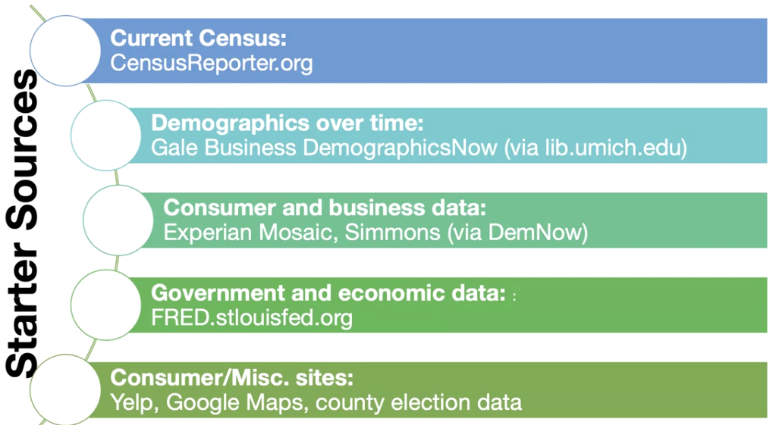

## Elements

* Mine is about incumbent vs new market
* The bigger the city the better
* Attendance is related to popularity, money, etc
* These are tiny leagues, where is hockey popular ? ? ? ?
* Its important to understand that the North is hockey territory, will people in Kentucky go ? families ?
* <https://www.federalhockey.com/directory>
* Ultimately this is entertainment…
* However, since the 1990s, ice hockey has become increasingly popular in the Sun Belt due in large part to the expansion of the National Hockey League to the southeast and southwest U.S., coupled with the mass relocation of many residents from northern cities with strong hockey support to these Sun Belt locations.
* What is your disposable income ?
* demographic ! ! !
* wealthier
* conservative
* recent building ?
* disposable income
* how much money are we talking about ? pretty cheap ! ! !
* credible
* persuasive arguments and persuasive ppt
* maximize revenue/profit, and minimize cost ! ! ! ! !
  + land is cheaper in kentucky ! ! ! ! versus michigan
  + market maximize market share
    - can can corner the hockey market in all of kentucky, there is NO competition ! ! !
    - minimize
  + exposure: maximize retention, minimize risk
  + market share ! ! ! ! !
    - how do I want to do this ? ? ?
  + new growth markets ! ! ! dallas stars
* white people ! ! ! ! kentucky ! ! ! !
  + no money
  + no money
  + no people
  + starting at ground zero ! ! ! ! ! ! would be difficult ! ! !
  + vioelent sport ! ! !

### HOCKEY

* Explain hockey overall
  + The [NHL](https://en.wikipedia.org/wiki/National_Hockey_League) is the major professional hockey league in North America, with 24 U.S.-based teams and 7 Canadian-based teams competing for the [Stanley Cup](https://en.wikipedia.org/wiki/Stanley_Cup)
  + how many people in attendance…
  + While NHL stars are still not as readily familiar to the general American public as are stars of the NFL, MLB, and the NBA, average attendance for NHL games in the U.S. has surpassed average NBA attendance in recent seasons,[[18]](https://en.wikipedia.org/wiki/Ice_hockey_in_the_United_States#cite_note-18)[[19]](https://en.wikipedia.org/wiki/Ice_hockey_in_the_United_States#cite_note-19) buoyed in part by the [NHL Winter Classic](https://en.wikipedia.org/wiki/NHL_Winter_Classic) being played in large outdoor stadiums.
  + hockey hall of fame is in minnesota
  + FanBase: Traditionally, ice hockey has been played predominantly by [Caucasians](https://en.wikipedia.org/wiki/White_American) in the United States and attended by white Americans and the [fans](https://en.wikipedia.org/wiki/Sports_fan) are the most affluent of the 4 major team sports watched in the United States.
  + Traditionally, ice hockey has been played predominantly by Caucasians in the United States and attended by white Americans and the fans are the most affluent of the 4 major team sports watched in the United States.[49][50][51][52]
  + Ice hockey is traditionally popular in Massachusetts, Michigan, and Minnesota within the United States. Minnesota is known as the hockey capital of the USA.
  + Is hockey more popular in Michigan than Kentucky ? Absolutely ! ! ! !
  + Despite a recent surge in the quality of the University of Louisville football team, and all UofL sports during the "year of the cardinal" or "Louisville slam", college basketball remains the sport of choice in most of Kentucky.
  + [College basketball](https://en.wikipedia.org/wiki/College_basketball) and [college football](https://en.wikipedia.org/wiki/College_football) are very popular in Louisville, which prides itself on being one of the best college sports towns in America.
  + <https://state.1keydata.com/nhl-teams-by-state.php>
  + Dallas Stars won stanley cup
  + The NHL audience is the richest of all professional sports
    - To play hockey, you do in fact need money ! ! !
  + The NHL Has The Least Diverse Audience For Its Championship Round
  + The NHL has always had a fan base with disposable income, which explains why games with preposterous ticket prices get sold out and Jersey Fouls get created. It’s the reason why, even in the years when hockey was an afterthought, the NHL has always been able to attract advertisers.
  + The NHL audience is the richest of all professional sports. One-third of its viewers make more than $100k, compared to about 19 percent of the general population.
    - We can assume that those that will watch will in fact be richer
  + **Create an approximate NHL or hockey demographic ! ! ! !**
  + income per capita,
  + A focus is placed on a variety of factors to attempt to determine what influences fan decisions to attend AHL hockey games. One key variable examined is the role of fighting,
  + The Effect of Distance from NHL Affiliate on AHL Fan Attendance
  + Several variables, such as winning percentage, promotional events, scheduling, and fighting, influence rates of attendance at professional sporting events, including minor league games.
  + **People will attend games when a team is hot…**
  + According to Mros, four possible psychological motives drive fans to attend AHL games: selfesteem, family, economics, and escape.
  + The family motive applies to fans that attend games in order to spend time with family members.
  + Psychological motives can cause not only diehard fans, but also people outside a team’s typical fan base to attend games.
  + They found that weekend games were more popular than games held during the week, and that games held later in the season were also more popular.
  + As the size of the population increased, game attendance also increased.
  + **Income per capita apparently had no significant effect on fan attendance in minor league hockey games.**
  + Specifically, certain regions across the nation appreciated different aspects of the minor league hockey game than other regions.

# OVERALL PERTINENT INFORMATION

**Elements**

* Examining economic stability
  + Housing prices are high, and thus you can afford entertainment
  + Migration
  + Correlates to economic success
* Bloomington, IN did in fact go under
* **Even small towns still have pretty good attendance ! ! !** 
  + NY: 20K people, but highest attendance !
* About:
  + The Federal Prospects Hockey League (FPHL) is committed to providing quality family entertainment at affordable prices in some of the most exciting new and established hockey markets in North America. We are also dedicated to the growth of professional hockey at the Class A level and creating a developmental ground not only for elite hockey players, but coaches and front office staff as well. We will strive to build dedicated, customer orientated staff; and provide fans, advertisers, sponsors, and partners with great value while operating at acceptable profit targets.
  + The FPHL has promoted and help advance over 500 players to various leagues including the AHL, ECHL, SPHL, and European leagues. The FPHL currently has teams in the following geographic areas such as Battle Creek MI, Columbus, GA; Danbury, CT; Danville, IL; Elmira, NY; Harrington, DE ; Mentor, OH; Port Huron, MI; Watertown, NY; and Winston-Salem, NC.
* Hockey is extremely popular in Wisconsin, Minnesota, Michigan, and ? ? ?
* What is KY known for ? ? ?
* Unusual:
  + One of the most successful is the Green NY team, but they are near nobody !
  + <https://en.wikipedia.org/wiki/Elmira,_New_York>
  + <https://www.elmiraenforcers.com/news/can-usa-sports-llc-excited-to-announce-usphl-comin>
  + Merchandise they have sold ?
* Who has the highest attendance ?
* <https://www.federalhockey.com/directory>

# LEXINGTON, KY

**Data**

* <https://en.wikipedia.org/wiki/Lexington,_Kentucky>
* <https://en.wikipedia.org/wiki/Fayette_County,_Kentucky>
* <https://en.wikipedia.org/wiki/Lexington,_Kentucky>
* Forbes

# FAYETTE COUNTY, KY

Main Source:

<https://censusreporter.org/profiles/05000US21067-fayette-county-ky/>

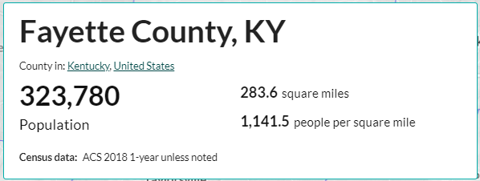

According to the [United States Census Bureau](https://en.wikipedia.org/wiki/United_States_Census_Bureau), the city has a total area of 285.5 square miles (739 km2). 284.5 square miles (737 km2) of it is land and 1.0 square mile (2.6 km2) of it (0.35%) is covered by water

The Lexington-Fayette metro area includes five additional counties: [Clark](https://en.wikipedia.org/wiki/Clark_County,_Kentucky), [Jessamine](https://en.wikipedia.org/wiki/Jessamine_County,_Kentucky), [Bourbon](https://en.wikipedia.org/wiki/Bourbon_County,_Kentucky), [Woodford](https://en.wikipedia.org/wiki/Woodford_County,_Kentucky), and [Scott](https://en.wikipedia.org/wiki/Scott_County,_Kentucky). This is the second-largest metro area in Kentucky after Louisville. According to the [United States Census Bureau](https://en.wikipedia.org/wiki/United_States_Census_Bureau), the city has a total area of 285.5 square miles (739 km2). 284.5 square miles (737 km2) of it is land and 1.0 square mile (2.6 km2) of it (0.35%) is covered by water.[[14]](https://en.wikipedia.org/wiki/Lexington,_Kentucky#cite_note-14)

The county is big, but also it is encompassed by a metro area known as Lexington-Fayette metro area with more counties. Second largest metro area in KY after Louisville.

Income: They do have good companies that work there

* **Fayette County** is part of the Lexington–Fayette, KY [Metropolitan Statistical Area](https://en.wikipedia.org/wiki/Lexington-Fayette,_KY_Metropolitan_Statistical_Area)
  + According to the [U.S. Census Bureau](https://en.wikipedia.org/wiki/U.S._Census_Bureau), the **county** has a total area of 286 square miles (740 km2), of which 284 square miles (740 km2) is land and 1.9 square miles (4.9 km2) (0.7%) is water
  + The city of Lexington, KY is consolidated entirely within [Fayette County](https://en.wikipedia.org/wiki/Fayette_County,_Kentucky)
  + 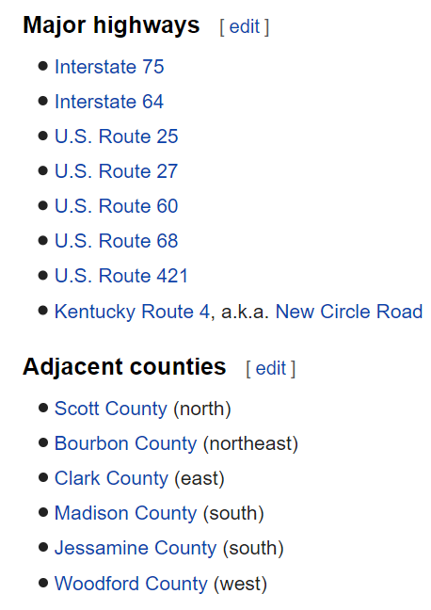
  + 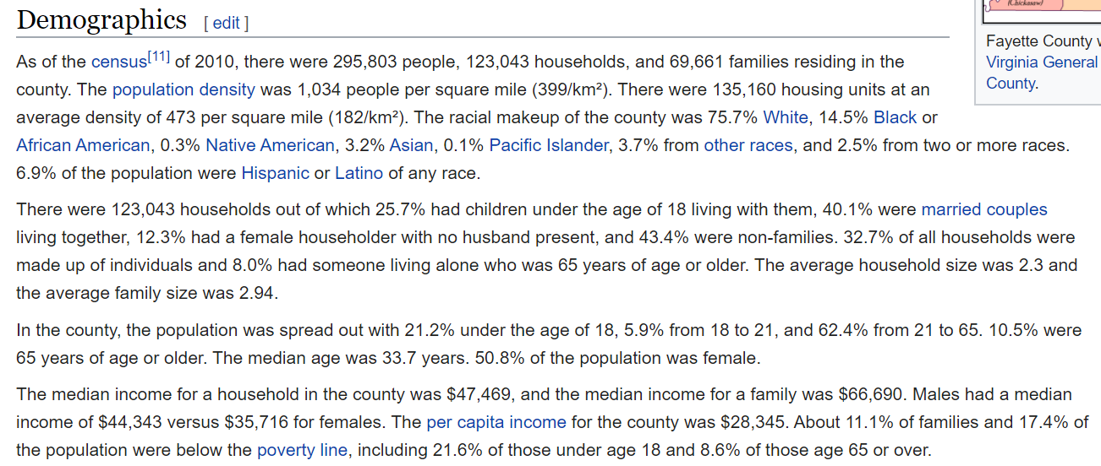
  + Unlike almost all of the rest of Kentucky, Fayette County has trended towards the Democratic Party in recent years rather than away from them. Between 1968 and 2004 it voted for the Republican nominee in all but one election. However, since 1996, it has seen close results for the two parties. In 2008, Barack Obama became the first Democrat to win a majority in the county since Lyndon Johnson in 1964. In 2016, Hillary Clinton won the county by the biggest margin since LBJ, although it was one of only two counties in the entire Commonwealth to vote for her, the other being Jefferson County, home to the city of Louisville.
    - they are democrats ! ! !
* Lexington is the second-largest city in Kentucky and the 60th-largest city in the United States. Known as the "Horse Capital of the World," it is the heart of the state's Bluegrass region. Notable locations in the city include the Kentucky Horse Park, The Red Mile and Keeneland race courses, Rupp Arena, Transylvania University, the University of Kentucky, and Bluegrass Community and Technical College. Lexington ranks 10th among US cities in college education rate, with 39.5% of residents having at least a bachelor's degree.[3]
* In the 2018 U.S. Census Estimate, the city's population was **323,780** anchoring a metropolitan area of 516,697 people and a combined statistical area of 760,528 people. By land area, Lexington is the 28th largest city in the United States. The city is consolidated entirely within **Fayette County**, and vice versa. It has a nonpartisan mayor-council form of government, with 12 council districts and three members elected at large, with the highest vote-getter designated vice mayor.
* Kentucky as a state:
* **Lexington** is the second-largest city in Kentucky and the 60th-largest city in the United States.
* Known as the "Horse Capital of the World," it is the heart of the state's Bluegrass region.
* Lexington: Horses
* Notable locations in the city include the Kentucky Horse Park, The Red Mile and Keeneland race courses, Rupp Arena, Transylvania University, the University of Kentucky, and Bluegrass Community and Technical College.
* Lexington ranks 10th among US cities in college education rate, with 39.5% of residents having at least a bachelor's degree.
* In the 2018 U.S. Census Estimate, the city's population was 323,780 anchoring a metropolitan area of 516,697 people and a combined statistical area of 760,528 people.
* By land area, Lexington is the 28th largest city in the United States.
* The city is consolidated entirely within Fayette County, and vice versa. It has a nonpartisan mayor-council form of government, with 12 council districts and three members elected at large, with the highest vote-getter designated vice mayor.A presentation that is five minutes long (plus or minus 15 seconds).
* [College basketball](https://en.wikipedia.org/wiki/College_basketball) and [college football](https://en.wikipedia.org/wiki/College_football) are very popular in Louisville, which prides itself on being one of the best college sports towns in America.
* White: 75.38% **Black** or African American: 14.39% Asian: 3.64% Two or more races: 3.60%
* <https://worldpopulationreview.com/us-cities/lexington-population/>
* With an estimated population of 323,780, Lexington is the second-largest city in Kentucky, behind [Louisville](https://worldpopulationreview.com/us-cities/louisville-population/), and the 60th-largest city in the [United States](https://worldpopulationreview.com/countries/united-states-population/).
* Lexington-Fayette, Kentucky Population 2020 323,780
* Southern Representation
  + Nashville TN, directly south of Kentucky by very few miles…
    - Nashville Predators NHL team ! ! !
* A focus is placed on a variety of factors to attempt to determine what influences fan decisions to attend AHL hockey games. One key variable examined is the role of fighting,
* In relation to the demographic fixed-effects, population was found to have a positive and significant effect on attendance, as larger cities attracted more fans. Income per capita was not found to have a significant effect on per-game attendance. The sign on income per capita was negative, suggesting some possibility of the AHL as an inferior good.
* For the overall AHL, expected results were found in relation to the timing of games. Weekend games were much more popular than weeknight games and attendance increased later in the season during the playoff push.
* Do they only play on the weekends ? ? ?
* **Per-game attendance was found to increase with the size of the population, but income per capita was not shown to have a significant effect.**
  + Price per ticket, call them and ask ! ! ! !

**Demographics for Lexington, KY**

* <https://en.wikipedia.org/wiki/Lexington,_Kentucky>
* **Lexington has one of the nation's most stable economies.**
* **The Lexington Metro Area had an unemployment rate of 3.7% in August 2015, lower than many cities of similar size**
* Kentucky as a state:
* **Lexington** is the second-largest city in Kentucky and the 60th-largest city in the United States.
* Known as the "Horse Capital of the World," it is the heart of the state's Bluegrass region.
* Lexington: Horses
* Notable locations in the city include the Kentucky Horse Park, The Red Mile and Keeneland race courses, Rupp Arena, Transylvania University, the University of Kentucky, and Bluegrass Community and Technical College.
* Lexington ranks 10th among US cities in college education rate, with 39.5% of residents having at least a bachelor's degree.
* In the 2018 U.S. Census Estimate, the city's population was 323,780 anchoring a metropolitan area of 516,697 people and a combined statistical area of 760,528 people.
* By land area, Lexington is the 28th largest city in the United States.
* The city is consolidated entirely within Fayette County, and vice versa. It has a nonpartisan mayor-council form of government, with 12 council districts and three members elected at large, with the highest vote-getter designated vice mayor.A presentation that is five minutes long (plus or minus 15 seconds).
* [*Forbes*](https://en.wikipedia.org/wiki/Forbes) has ranked Lexington 10th place in the world's cleanest cities.
* Lexington must manage a rapidly growing population while working to maintain the character of the surrounding horse farms that give the region its identity. I
* Wikipedia:
* The Lexington-Fayette Metropolitan Statistical Area (MSA) includes Bourbon, Clark, Fayette, Jessamine, Scott, and Woodford Counties. The MSA population in 2015 was estimated at 500,535.[24] The Lexington-Fayette-Frankfort-Richmond, KY Combined Statistical Area had an estimated population of 723,849 in 2015.[25] This includes the metro area and an additional seven counties.[26]
* Map of racial distribution in Lexington, 2010 U.S. Census. Each dot is 25 people: White, Black, Asian, Hispanic or Other (yellow)
* As of the census[27] of 2010, 295,803 people, 125,752 households, and 62,915 families resided in the city. The population density was 1,042.8 people per square mile (353.5/km²). The 135,160 housing units averaged 408.3/mi² (157.6/km²). The racial makeup of the city was 75.7% White, 14.5% Black or African American, 0.3% Native American, 3.2% Asian, 0.03% Pacific Islander, 1.21% from other races, and 2.5% from two or more races. Hispanic or Latinos of any race were 6.9% of the population.
* Of the 125,752 households, 27.3% had children under the age of 18 living with them, 43.5% were married couples living together, 11.5% had a female householder with no husband present, and 41.9% were not families; 31.7% of all households were made up of individuals, and 7.5% had someone living alone who was 65 years of age or older. The average household size was 2.29 and the average family size was 2.90.
* In the city, the population was distributed as 21.3% under the age of 18, 14.6% from 18 to 24, 33.2% from 25 to 44, 20.9% from 45 to 64, and 10.0% who were 65 years of age or older. The median age was 33 years. For every 100 females, there were 96.5 males. For every 100 females age 18 and over, there were 94.3 males.
* The median income for a household in the city was $49,778, and for a family was $53,264. Males had a median income of $36,166 versus $26,964 for females. The per capita income for the city was $30,031. About 8.2% of families and 18.9% of the population were below the poverty line, including 14.3% of those under the age of 18 and 8.6% of those ages 65 and older.
* The city is home to several large corporations. Sizable employment is generated by four [*Fortune* 500](https://en.wikipedia.org/wiki/Fortune_500) companies: [Xerox](https://en.wikipedia.org/wiki/Xerox) (which acquired [Affiliated Computer Services](https://en.wikipedia.org/wiki/Affiliated_Computer_Services)), [Lexmark International](https://en.wikipedia.org/wiki/Lexmark_International), [Lockheed-Martin](https://en.wikipedia.org/wiki/Lockheed-Martin), and [IBM](https://en.wikipedia.org/wiki/IBM), employing 3,000, 2,800, 1,705, and 552, respectively.[[38]](https://en.wikipedia.org/wiki/Lexington,_Kentucky#cite_note-ME-38) [United Parcel Service](https://en.wikipedia.org/wiki/United_Parcel_Service), [Trane](https://en.wikipedia.org/wiki/Trane), and [Amazon.com, Inc.](https://en.wikipedia.org/wiki/Amazon.com) have large operations in the city, and [Toyota Motor Manufacturing Kentucky](https://en.wikipedia.org/wiki/Toyota_Motor_Manufacturing_Kentucky) is within the Lexington CSA, located in adjoining [Georgetown](https://en.wikipedia.org/wiki/Georgetown,_Kentucky). A [Jif](https://en.wikipedia.org/wiki/Jif_(peanut_butter)) [peanut butter](https://en.wikipedia.org/wiki/Peanut_butter) plant located here produces more peanut butter than any other factory in the world.[[39]](https://en.wikipedia.org/wiki/Lexington,_Kentucky#cite_note-FUNTIDBITS-39)

**Airport for Lexington, KY**

* Known as the "Horse Capital of the World," it is the heart of the state's Bluegrass region.
* Lexington: Horses

# COMPARISONS

## COMPARISON - SPORTS REPRESENTATION

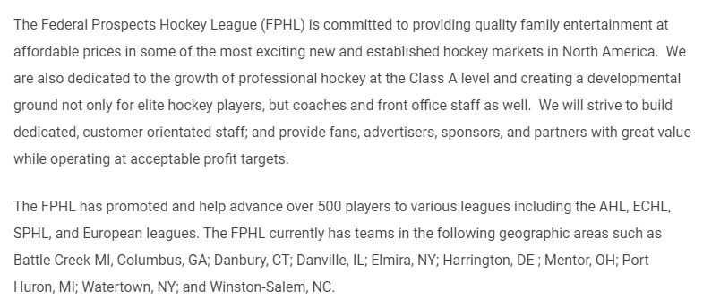

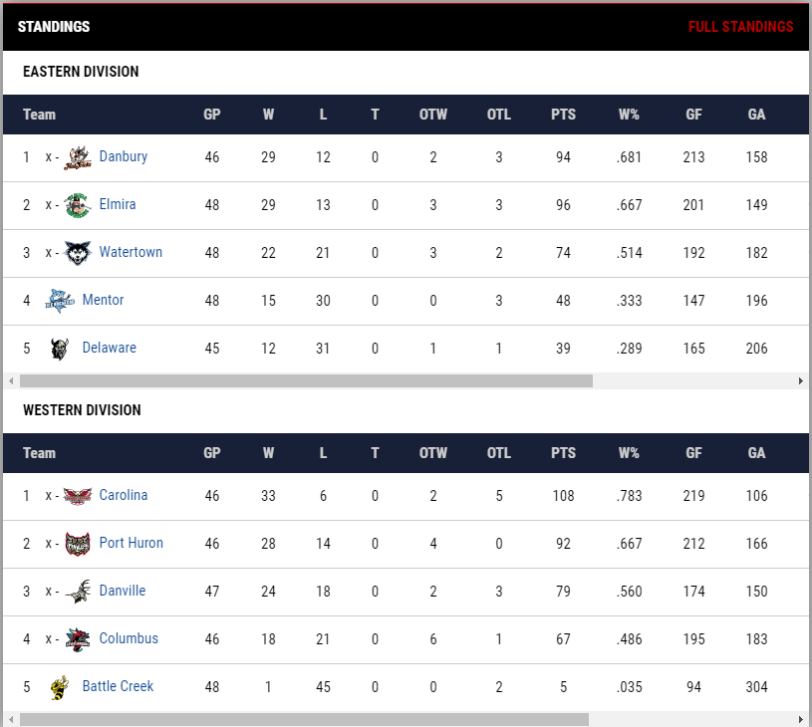

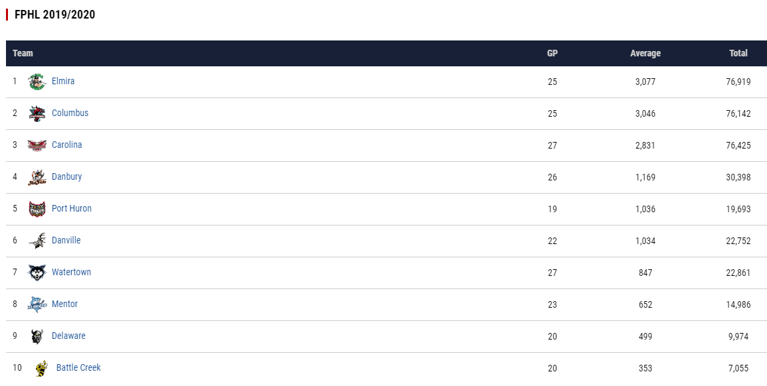

**Columbus GA** has second highest ! Columbus, GA

Carolina Thunderbirds third highest population !

**Winston-Salem, NC Carolina Thunderbirds , and that is not a hockey town ! ! !**

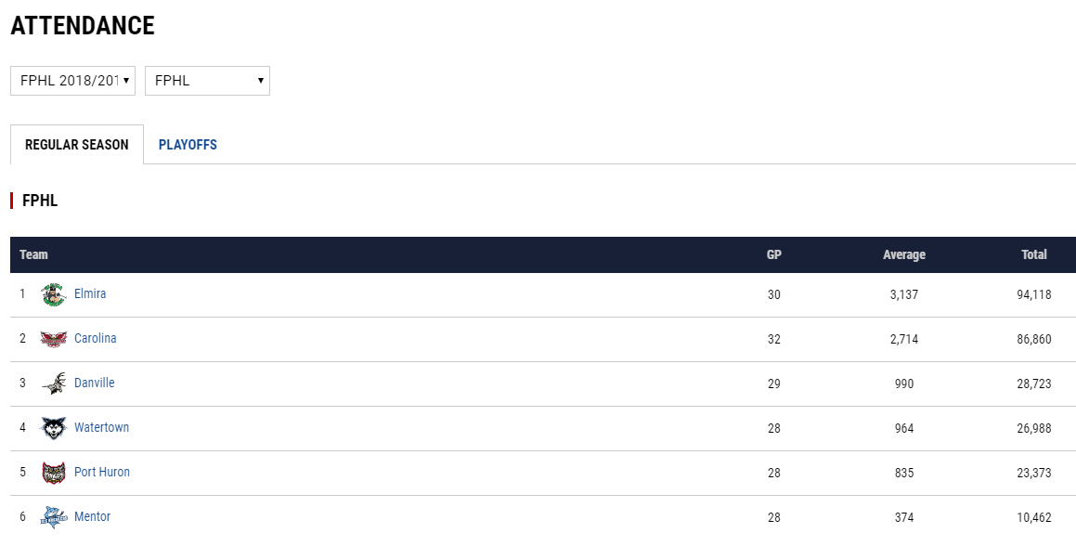

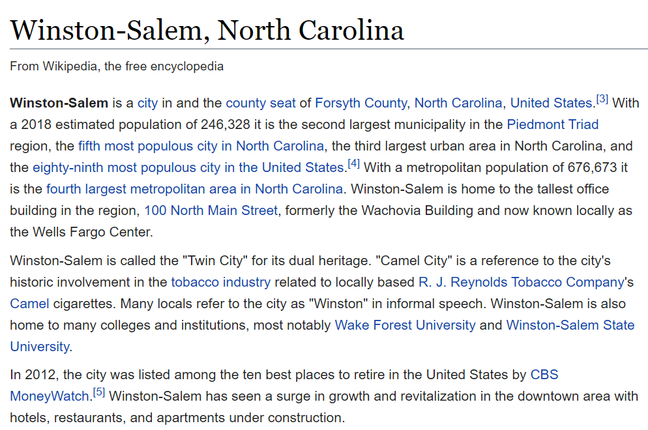

*Map this out ?*

*Successful locations tend to be in thriving, smaller cities* ***not*** *already served by National Hockey League (NHL), large university teams or major-league sports teams.*

I would say this was a smaller city

Louisville to Lexington as Dallas to Ft. Worth

* College:
  + LEX
    - University of Kentucky is located in Lexington, KY
    - Basketball and lately football
    - The [Kentucky Wildcats](https://en.wikipedia.org/wiki/Kentucky_Wildcats), the athletic program of the University of Kentucky, is Lexington's most popular sports entity.
    - The school fields 22 varsity sports teams, most of which compete in the [Southeastern Conference](https://en.wikipedia.org/wiki/Southeastern_Conference) as a founding member.[[56]](https://en.wikipedia.org/wiki/Lexington,_Kentucky#cite_note-56) The [men's basketball team](https://en.wikipedia.org/wiki/Kentucky_Wildcats_men%27s_basketball) is one of the winningest programs in [NCAA](https://en.wikipedia.org/wiki/NCAA) history, having won eight national championships. The basketball program was also the first to reach 2000 wins,[[57]](https://en.wikipedia.org/wiki/Lexington,_Kentucky#cite_note-57) and is currently coached by [John Calipari](https://en.wikipedia.org/wiki/John_Calipari). Another program, the [Transylvania University Pioneers](https://en.wikipedia.org/wiki/Transylvania_University), compete in [NCAA Division III](https://en.wikipedia.org/wiki/NCAA_Division_III) athletics.
  + SJO
    - Nearby Chicago locations
    - Nearby ?
* Professional Sports:
  + LEX
    - no nhl team
    - nearest team: chicago !
    - Lexington is home to the [Lexington Legends](https://en.wikipedia.org/wiki/Lexington_Legends), a Class A minor-league affiliate of the [Kansas City Royals](https://en.wikipedia.org/wiki/Kansas_City_Royals) as of 2012.[[58]](https://en.wikipedia.org/wiki/Lexington,_Kentucky#cite_note-58) Since its inception in 2001, Lexington has produced numerous major leaguers, including 2009 National League All-Star [Hunter Pence](https://en.wikipedia.org/wiki/Hunter_Pence) (outfielder), [John Buck](https://en.wikipedia.org/wiki/John_Buck_(baseball)) (catcher), [Mike Gallo](https://en.wikipedia.org/wiki/Mike_Gallo) (pitcher), [Chaz Roe](https://en.wikipedia.org/wiki/Chaz_Roe) (pitcher), and [Josh Anderson](https://en.wikipedia.org/wiki/Josh_Anderson_(baseball)), (right fielder). The Legends belong to the [South Atlantic League](https://en.wikipedia.org/wiki/South_Atlantic_League), and have three league titles (2001, 2018, 2019) and six playoff appearances since 2001. [Roger Clemens](https://en.wikipedia.org/wiki/Roger_Clemens) pitched in one game for the Legends in 2006 as part of his preparation to return to the [Houston Astros](https://en.wikipedia.org/wiki/Houston_Astros).
    - Newspaper: <https://en.wikipedia.org/wiki/Lexington_Herald-Leader>
  + SJO
    - no nhl team
    - nearest team: nashville tn
* Thoughts
  + if you live in michigan, who do you follow in terms of hockey ? detroit red wings, one of the best teams
  + if you live in michigan, you have ann arbor hockey college
  + Fri Oct 18 is when season starts ! ! ! ! and goes thru: Sun Apr 5
  + they almost exclusively play on the weekdns ! ! ! ! ! ! ! ! fri/sat/sun
  + \
  + UK basketball: Tue, Nov 5 thru… april 2nd ; but they play Tuesdays, sat, Tuesday, Friday, Tuesday, wad,

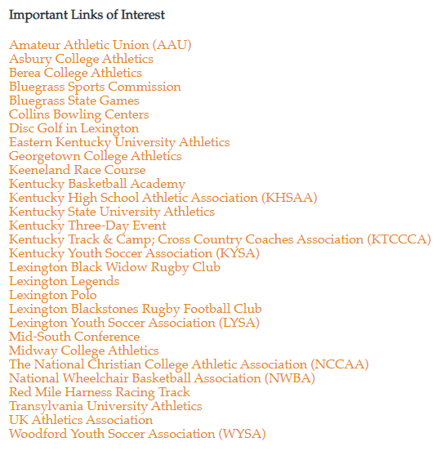

Case In Point: Battle Creek MI had the lowest attendance !

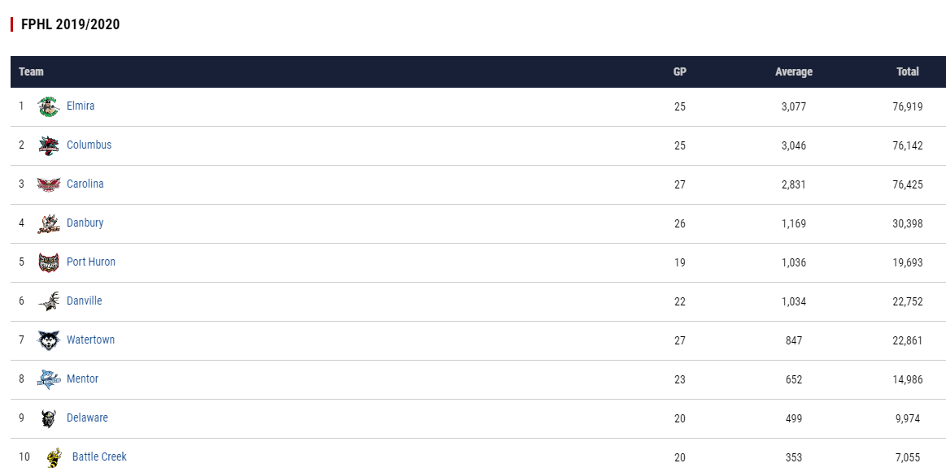

## COMPARISON - COUNTY

SJO

According to the [United States Census Bureau](https://en.wikipedia.org/wiki/United_States_Census_Bureau), the city has a total area of 4.80 square miles (12.43 km2), of which 3.22 square miles (8.34 km2) is land and 1.58 square miles (4.09 km2) is water.[[23]](https://en.wikipedia.org/wiki/St._Joseph,_Michigan#cite_note-Gazetteer_files-24)

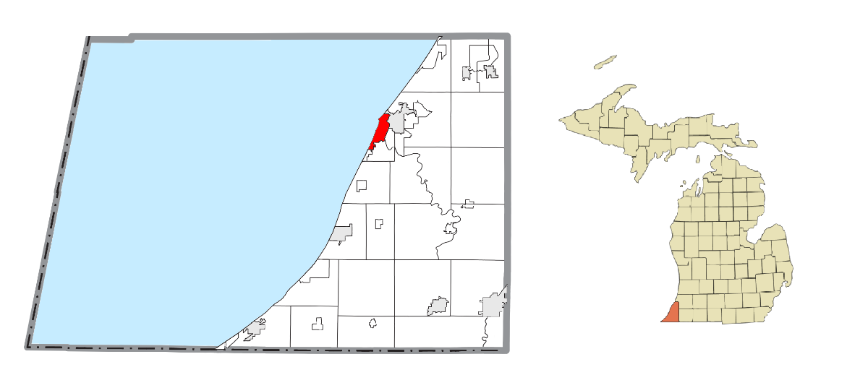

## COMPARISON - AIRPORTS

[Blue Grass Airport](https://en.wikipedia.org/wiki/Blue_Grass_Airport) is Lexington's primary commercial airport. It provides about 13 nonstop flights and a total of 86 flights daily from its two runways. Four major airlines operate connection service at Blue Grass, including [Allegiant Air](https://en.wikipedia.org/wiki/Allegiant_Air), [American Eagle](https://en.wikipedia.org/wiki/American_Eagle_(airline_brand)), [Delta Air Lines](https://en.wikipedia.org/wiki/Delta_Air_Lines), and [United Express](https://en.wikipedia.org/wiki/United_Express).

On August 27, 2006, [Comair Flight 5191](https://en.wikipedia.org/wiki/Comair_Flight_5191) took off from the wrong runway, and crashed in a nearby field, killing 49 of the 50 passengers, leaving the first officer alive but badly burned. The aircraft involved was a 50-seat Bombardier Canadair Regional Jet CRJ-100ER, serial number 7472. On August 27, 2011, a memorial sculpture depicting 49 steel birds flying was unveiled and dedicated to the victims.

The airport is located 4 mi (6 km) west of the city center, at the intersection of [US 60](https://en.wikipedia.org/wiki/U.S._Route_60_in_Kentucky) (Versailles Road) and Man o' War Boulevard.

In addition to commercial airline service, the airport is also home to several private (general aviation) operators, including TACAir, which serves as the airport's fixed-base operator. Flight training and aircraft maintenance services are also offered. A new general aviation runway was dedicated August 4, 2010.

Lexington, KY does it have an airport ?

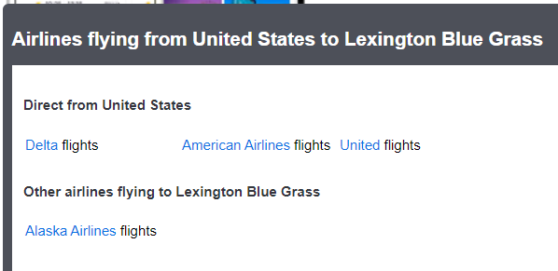

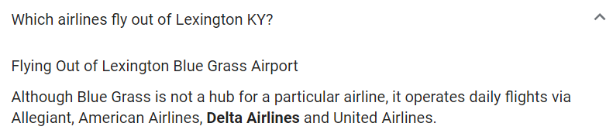

<https://en.wikipedia.org/wiki/Blue_Grass_Airport>

Blue Grass Airport is the primary airport serving central and eastern Kentucky

More than 1.3 million passengers depart or arrive annually at Blue Grass Airport. In 2017, the airport served 1,316,847 passengers via four major airline carriers: [Allegiant Air](https://en.wikipedia.org/wiki/Allegiant_Air), [American Airlines](https://en.wikipedia.org/wiki/American_Airlines), [Delta Air Lines](https://en.wikipedia.org/wiki/Delta_Air_Lines) and [United Airlines](https://en.wikipedia.org/wiki/United_Airlines)

# COMPARISON - FINANCE

<https://censusreporter.org/profiles/16000US2670960-st-joseph-mi/>

<https://censusreporter.org/profiles/05000US26021-berrien-county-mi/>

<https://censusreporter.org/profiles/16000US2146027-lexington-fayette-ky/>

<https://censusreporter.org/profiles/05000US21067-fayette-county-ky/>

## COMPARISON - DEMOGRAPHICS

<https://search.lib.umich.edu/databases/record/30002>

<https://search.lib.umich.edu/databases/record/30002>

<https://dnow-gale-com.proxy.lib.umich.edu/dnow/?p=DNOW&u=lom_accessmich>

<https://dnow-gale-com.proxy.lib.umich.edu/dnow/?p=DNOW&u=lom_accessmich>

people that attend UK game are students ! ! ! !

family ! ! ! !

My recommendation: ask them about hockey. hockey outreach program

